Remaining Tasks:

Can do:

* Search for township
  + Data is separated into different fields. There is a field that has combined all TRS though
  + 
  + 
* Add “type ahead” to search bar for address query
* Zoom to Feature only return CCR with images
  + Just need to change the layer that it accesses
* Clicking on an R-Monument it calls it a “Regional Coastal Monitoring Data”
  + I believe this is correct, see: <http://geodata.dep.state.fl.us/datasets/coastal-range-monument-locations/geoservice?geometry=-130.466%2C21.699%2C-46.399%2C35.175>
* Township/Range lines are not showing (they’re part of a separate service)
  + We can probably bring this back to the same service. It was changed because the buffering ability can only be done when data is projected into Web Mercator.

Can do with time:

* Style legend
  + Create permanent border on bottom
  + Change background color
* Style the print widget
* Change rendering of Erosion Control Line to test the rendering capabilities (see if it overrides what is currently defined

Unknown:

* Display only image fields where CCR has image
  + This can be partially accomplished by inserting the image URL instead of “here”. If there is no URL to display, then there is no link that can be displayed. However this does not solve the problem of condionally displaying all images yet.   
    
  + 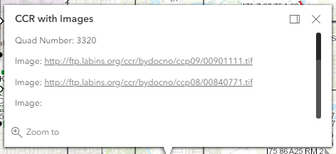
  + This might be possible to accomplish with an Arcade expression
* Undock panels and move freely around screen
* Movable popup box
* Bookmarks
  + Not currently supported, there may be a workaround created in the community
* Clicking on the “download report: here” link of a tide interpolation is not working:
  + This is building a url from the fields. This doesn’t work when there is a 2 word quad.
* Test displaying legend items under each